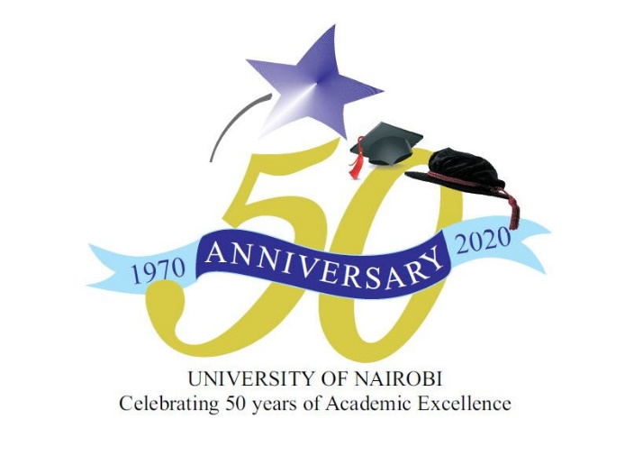
COLLEGE OF BIOLOGICAL AND PHYSICAL SCIENCES
UON @50 CELEBRATIONS
Schedule of activities

Date | Activity10am to 1pm) | Incharge
27 May 2021 | Launch of CBPS UON@50 celebrations | Dr. C. Lukhoba
28thMay 2021 | Alumni talks | Prof. R. Oboko
3rd June 2021 | Student merit – talks | Dr. G. Obiero
4th June, 2021 | Webinar (Prof Thomas- Covid-19) | Prof. L. Kerubo/Prof. S. Luketero
10th June, 2021 | Inaugural lecture | Prof.D. Olago
11th June, 2021 | Student innovation /research awards | Dr.C. Lukhoba
17th June, 2021 | Webinar (AAS talk) | Prof. L. Kerubo/Prof. S. Luketero
18th June, 2021 | Inaugural lecture | Prof. D. Olago
24th June, 2021 | 1.Webinar (Pestidals)  2. Mathematics | Dr Lukhoba  Prof. S. Luketero
25th June 2021 | Closure of CBPS UON@50 celebrations- Alumni talks | Dr. C. Lukhoba/Prof. R. Oboko

